Sunny Patel
CS360
Kurt Schmidt
HW1 – FSM

- Provide an NFA for each fo the following REs, following the rules of construction provided in class, or in the CS270 text.

  - x(y|z)(a|b)*
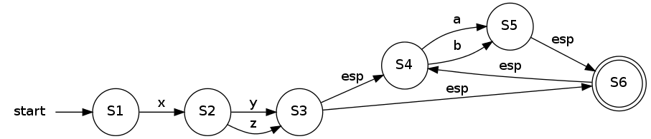
  - ((xy|z)(a|b))*
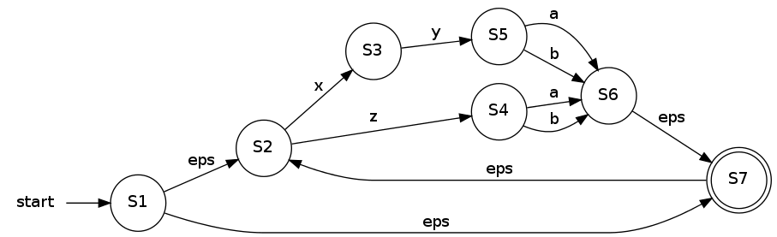
  - x|yza|b*
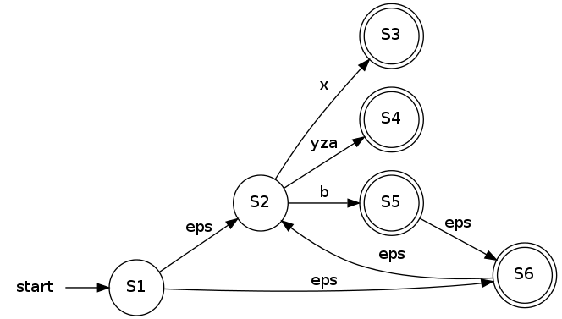

- Given the following FSM, determine if each of the following strings is accepted.
  - Xxx – accepted
  - yxyz – accepted
  - yxxyxxy – accepted
  - zyy – accepted
  - zyyx – accepted
  - zyyxy – accepted
  - eps - accepted

- Converted NFA to a DFA
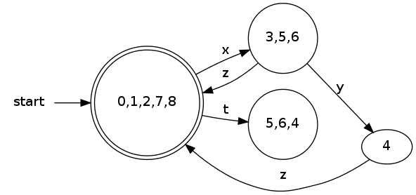
- For each of the following, provide a FSM that accepts the language described:
  - Strings of 1s and 0s, where the number of 1s is a multiple of 3
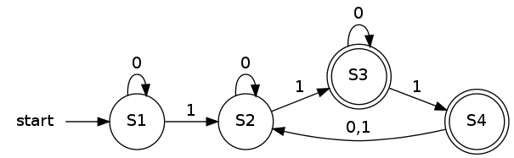
  - Strings of 1s and 0s, where the number of 1s is odd, and the number of 0s is even
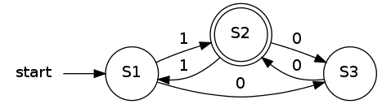

  - Given a binary number (strings of 1s and 0s), determine if the number is divisible by 3

